DSA0502 – QUERY PROCESSING FOR DATA SCIENCE
LAB PROGRAMS
NAME: B KIRTHANAA REG. NO – 192324244

7. Write a Pandas program to create a Pivot table and find the maximum and minimum sale value of the items.
Aim:
To create a Pivot Table using Pandas and find the maximum and minimum sale value of each item.
CODE:
import pandas as pd
# Create dataset
data = {
"Item": ["Pen", "Pen", "Book", "Book", "Pencil", "Pencil"],
"Sale": [50, 70, 120, 150, 30, 40]
}
df = pd.DataFrame(data)
# Pivot Table
pivot = pd.pivot_table(df, values="Sale", index="Item", aggfunc=["max", "min"])
print(pivot)

OUTPUT:
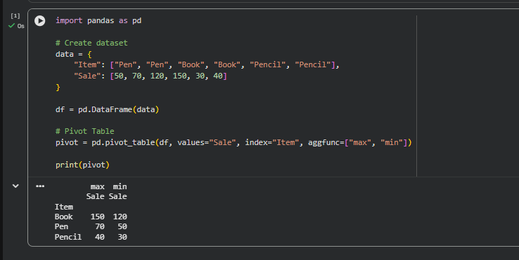
8. Write a Pandas program to create a Pivot table and find the item-wise units sold.
Aim
To create a Pivot Table using Pandas and find the total units sold for each item.
CODE:
import pandas as pd
# Create dataset
data = {
"Item": ["Pen", "Pen", "Book", "Book", "Pencil", "Pencil"],
"Units": [10, 15, 20, 25, 30, 35]
}
df = pd.DataFrame(data)

# Pivot Table
pivot = pd.pivot_table(df, values="Units", index="Item", aggfunc="sum")
print(pivot)

OUTPUT:
